Midwest and Southwest seem to be worst performing sectors:

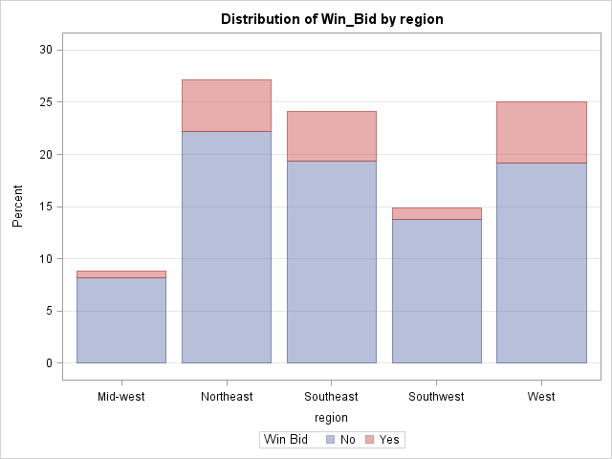

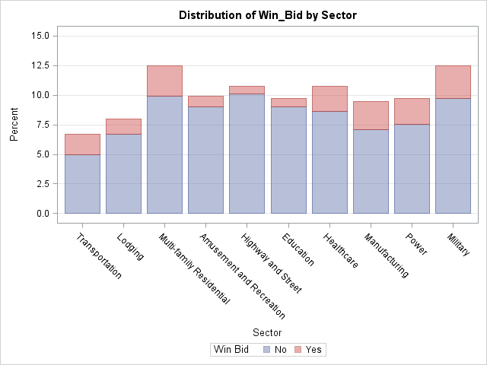

Quasi Complete separation winning bid and bid price -> eliminated winning bid, because it is not known. Possibly, it can be another target variable.

Extreme odds ratio in Comp_G. Comp_G, C and D together resemble a typical key competitor as to the regional distribution. Combined those to reduce variables without losing any information.